DEVELOP A WEBSITE TO ASSIST GCSE STUDENTS WITH THEIR EXAM REVISION



Extended Project Qualification

July 2018 – December 2018

By Esteban Lanza

Abstract

This project concentrates on the creation and development of an education focused website, which main focus is to attract and retain teenage audiences with a website containing revision resources. The intention of this web page is to supply content related to the core GCSE subjects to students that need it for their exam’s revision.

In this project I explored the different ways of creating a website that is suitable for my target audience with the programming skills acquired from past experiences and the help of a diversity of sources such as articles and academic research.

Research

## **- How to make a website attractive to teenagers?**

The main focus of my website is to be able to offer a wide range of useful GCSE revision material for students who are currently taking subjects such as Maths, Science and English. Therefore the younger audience is the target for the website. *This generation is much more tech savvy than previous generations, and their values and styles of navigating, shopping and using the internet have changed. (*John stone, 2016*)* In summary, the ‘Gen Z’ are after a few things: fast and convenient information, content that’s funny and personal, and products and services that focus on their long term goals while also giving them instant gratification.

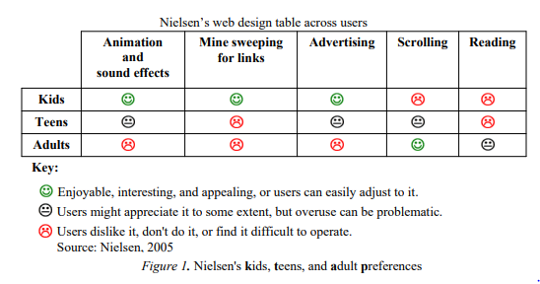

Based on this graph (Anthony S. Chow, Kathelene McCarty Smith

and Katherine Sun, 2012), is fair to assume that teens are one of the most demanding age groups as their requirements from a website are quite high and meticulous. From is table I can deduce the functions that my website should, or shouldn’t have, like:

Do: animation effects e.g. Info carousel. This adds a more modern look to the website which is what teens are looking for.

Do: add some scrolling to the page. Some scrolling in the page is necessary as the is a lot of information to share in the website, but I should keep it limited as

Don’t: add advertising. Although is represented as a neutral view in the table, ads are often considered annoying, which usually leads to a website being less attractive and entertaining.

Don’t: create long texts as teenagers may grow tired of reading through useless information that they are not interested in.

## **- Programming languages to design and create a website**

In order to start creating the website I had to do extensive research on the different existing languages that are often used in web developing. By querying this question in a search engine, I found that websites are often built in two parts: Front-End and the Back-End. *The front-end is everything involved with what the user sees, including design and some languages like HTML and CSS* *and the Back-End is basically how the site works, updates and changes* (Pluralsight, 2015). Based on this information I started searching for ways to learn HTML and CSS in order to begin with the development of the website. I later found out of SoloLearn, a platform which offers free courses on both HTML and CSS to 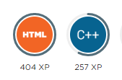anyone with an account in their website. After I created my own account, I proceeded to start with the HTML course which was promoted to take around 8 hours to complete. In this course I learned the basics of this Hypertext Mark-up Language and acquired the skills to create simple websites and using APIs in them. After I completed this course, I started the CSS course which was advertised as a much longer course than the HTML (12 hours). I only completed about 60% of this course due to timing reasons, as I thought I was spending too much time learning the languages and was leaving the development of the website too far behind. Nevertheless, by doing this course I learned how to manipulate text and colours in a website as well as how to place images and make them look in different shapes.

## **- What type of content do I need for the subjects?**

For all of the subjects (Maths, English and science) I’m going to be looking only at what content is recommended for the Key Stage 4 course, which is equivalent to the last two years of the GCSE curriculum (Also known as Year 10 and 11). By only searching for this type of information I will be able to select much more specific content for the website, therefore making it much more useful.

In order find up-to-date information on what each subject’s main topic are I selected the National curriculum provided by the government on each subject. For every subject there is a KS4 (key stage 4) area where all the topics are shown and explained. I selected this resource as it was the most reliable and easy to use. This is the information I found out about each subject:

Maths: for mathematics at KS4 the main requirements were: Algebra, Ration, proportion, rates of change, geometry and measures, probability and finally statistics. (Department for Education 2014*)*

English: for English at KS4 the main requirements were: it focuses on spoken language, which challenges students to increase their vocabulary. Reading, which encourages students to read different books or novels from the 19th, 20th and 21st centuries. Writing, which teaches to write accurately, effectively and at length for pleasure and information. (Department for Education 2014*)*

Science: Through the content across all three disciplines, students should be taught so that they develop understanding and first-hand experience of Science. The main topic areas are: Biology, Chemistry and Physics, all of which contain a vast number of subtopics that suit each area. (Department for Education 2014*)*

With this information about the main requirements of each subject I can now work on finding resources online that would contain the named topics.

Bibliography

1. Anthony S. Chow, Kathelene McCarty Smith and Katherine Sun (2012) ‘*Youth as Design Partners: Age-Appropriate Websites for Middle and High School Students’* https://www.researchgate.net/publication/298450861_Youth_as_Design_Partners_AgeAppropriate_Websites_for_Middle_and_High_School_Students (Accessed: 06 November 2018).
2. John stone (2016) *‘Millennial Appeal: How to Design a Website to Attract the Younger Audience’* https://webdesignledger.com/millennial-appeal-how-to-design-a-website-to-attract-the-younger-audience/#c4372342cc(Accessed: 13 September 2018)
3. Pluralsight (2015) *‘What's the Difference Between the Front-End and Back-End?*’ <https://www.pluralsight.com/blog/film-games/whats-difference-front-end-back-end> (Accessed: 15 September 2018)
4. Department for Education (2014*) ‘National curriculum in England: mathematics programmes of study’* <https://www.gov.uk/government/publications/national-curriculum-in-england-mathematics-programmes-of-study/national-curriculum-in-england-mathematics-programmes-of-study> (Accessed: 30 September 2018)
5. Department for Education (2014*) ‘National curriculum in England: English programmes of study’*  <https://www.gov.uk/government/publications/national-curriculum-in-england-english-programmes-of-study/national-curriculum-in-england-english-programmes-of-study#key-stage-4> (Accessed: 30 September 2018)
6. Department for Education (2014*) ‘National curriculum in England: science programmes of study’* <https://www.gov.uk/government/publications/national-curriculum-in-england-science-programmes-of-study/national-curriculum-in-england-science-programmes-of-study#key-stage-4> (Accessed: 30 September 2018)

Website Project Brief

## **- Client Contact Details**

Corporation name: StudySesh

Name of the website: StudySesh

## **- Budget and Timing**

I’m aiming to create a website from scratch without spending any money on it. Therefore my budget will be £0. In terms of the launch date, I’m confident that by mid-October the website will be online and fully operational.

## **- Project outline**

The main purpose of StudySesh is to aid GCSE students in their revision by providing resources like past papers and subject aimed notes. The website will also help students find useful material for revision such as YouTube video tutorials or other websites that might help them, by offering them a section with numerous sources linking to this materials.

The client will expect me to code a website that seems original and is attractive to young audiences (13 to 17 years old), as this website is aimed for GCSE students. He will also expect the website to have content that is relevant and interesting to teenagers, so that they are engaged to the website.

## **- Exemplar websites**

* 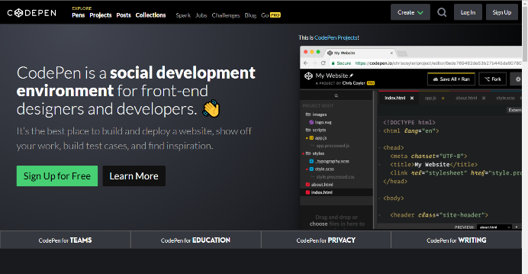Codepen is a great example of how I want my website to look like, design wise. The navigation bar is quite simple but very modern and interactive which fits with the style of website I want to create. Nevertheless, I won’t be using the dark colours that Codepen is using as they don’t suit my target audience.
* 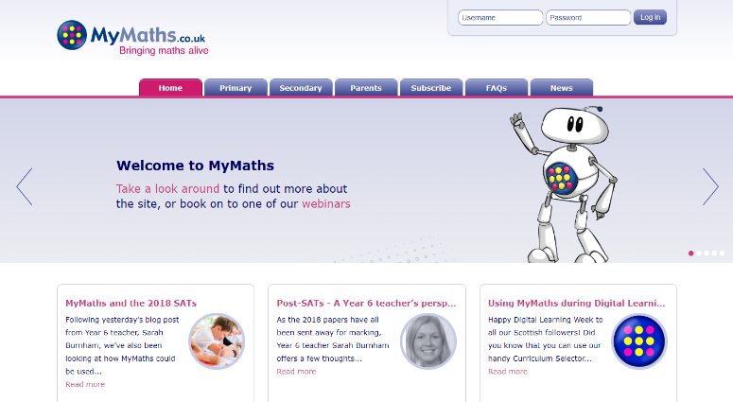MyMaths is a great example of how I would use neutral colours in my website. I also like the ease of navigating through the site, as all the options are displayed in the navigation bar with a proper title name that fully explains what that page is going to be about. Nevertheless, MyMaths’ website design doesn’t fit what I’m looking for in my website as it seems quite outdated and boring.

## **- Website architecture**

Coding languages:

- HTML5/CSS5: I will use this languages in order to create the basic layout of the website and to also produce the design for it.

- Bootstrap: I will use this language to add interactive features to my website like an image carousel. Bootstrap will also allow me to adapt the size of my website to different devices, which means that my website will be more available to users.

## **- Web style and design**

|  |  |
| --- | --- |
| Design/Coding languages | I will use CSS3 in order to style my website as it is the most advanced and efficient version of CSS and is also the general language to design websites. |
| Design | Futuristic/Modern/State-of-the-art: in order to comply with my target audience’s taste. |
| Colours | I will be using neutral colours: Red, neutral blue and black. |
| Interactive | It’s going to include interactive features such an image carousel, and interactive navigation bar. |

## **- Connected social media**

In order to reach out to my target audience I will be creating 2 different social media pages. This will be Twitter and Facebook. Social media pages will be displayed in my website as favicons that users can click on if they want to see/follow them.

Once the social media is created I will be uploading news and updates about my website, but also they will be a great tool to interact with my users and to get feedback from them.

Social media will only be created if the website is launched at the end of the project, so that no time is wasted in creating something without a use.

## **- Content**

|  |  |
| --- | --- |
| Client | Information about the client in the about me page. |
| Information | - General exam advice for students doing their GCSEs  - Best resources/exam papers to use in order to prepare for exams |
| Interactive content | - Image carousel for users to see the latest news about exams or website updates.  - Small games for users to test their skills on.  - Links to products to amazon by using the amazon API. |
| Subject specific content | - Links to useful YouTube videos.  - Past papers and revision materials.  - Recommended material for the subject (books and equipment) |

## **- Monetization**

In order to benefit from the creation of this website, I will need to monetize it. I will do this in a way that my audience is not negatively affected by it, which rules out ads as they are annoying for young audiences.

I decided to monetize my website by doing a non-conventional online store. In this store user will be able to see different products such as books, school equipment etc. but the users will not be able to buy it from my website. Instead, in the product information there will be a link sending them to the product in Amazon. I will do it this way so that I benefit from the Amazon Associates Program, which will give me 10% of the total price of the products the user buys from my link.

## **- Competition and niche**

I'm aiming to introduce my website to the niche market of GCSE material and education websites. This is a market that is very competitive in the UK. Websites like MyMaths, Student room and StudyWise are the main competition as all of them offer a wide range of GCSE material in their sites, and they also have great monetization schemes making them very versatile and efficient.

In order to make my website more competitive than the others I will have to innovate in a unique way that my target audience will be attracted to.

Development Section

# Ideas for the project

The idea of making a website has always been in my head. I find them really mysterious, but interesting at the same time, which it makes it the perfect topic to do an EPQ on it. When deciding about the type of website that I was going to build, I thought about different ideas and topics that would be both easy and relatable to me as a student, such as:

* A website with simple games created by me. This idea was scrapped due to how time consuming it could have been.
* A website/online-shop that advertised on-demand products that are being sold in amazon or eBay. I decided not to proceed with this idea as I don’t know how to manipulate API’s at this level.
* A website with revision material for GCSE students. I went for this choice as it is something that I know a lot about and it’s highly relatable to me.

# Planning of the website

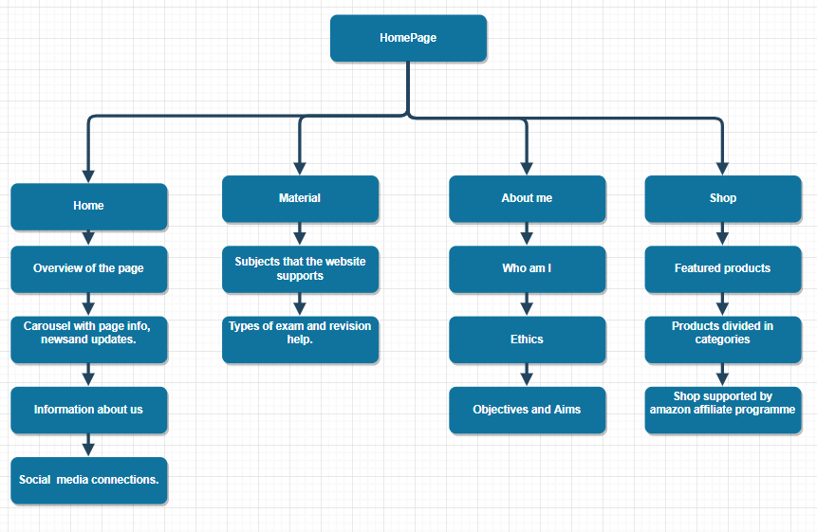At the beginning of the project I had to do a plan of how I will structure the website. My research indicated that by doing this not only I will save time later on but it will be easier to code as I already have a general idea of how the website will look like.

I started by creating a flowchart of the homepage of the website, which is the page that the user will first see when entering my website. In this flowchart I specified not only what I was going to put in the homepage, but also the topics that I was going to put in the other pages (about-us, materials etc.) as well. Later on in the project I decided that this flowchart wasn’t suitable for the project anymore as I was not going to do the shop due to timing issues. This led me to create another Homepage flowchart.

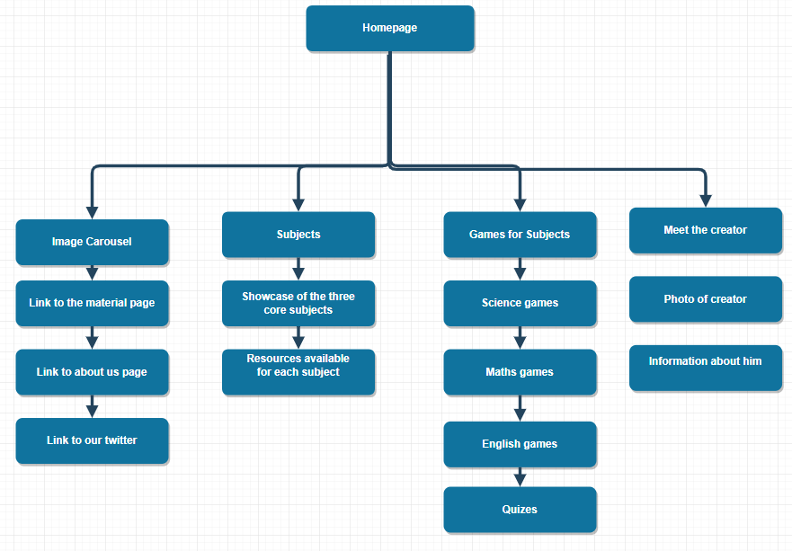The final flowchart for the homepage included all the specific topics that are covered in the homepage only. In this flowchart I portrayed all the different sections on the page and its respective content within them.

After doing this flowchart, the design of the website seemed clearer that before which help me a lot when coding the website, as it gave me a clear structure to follow.

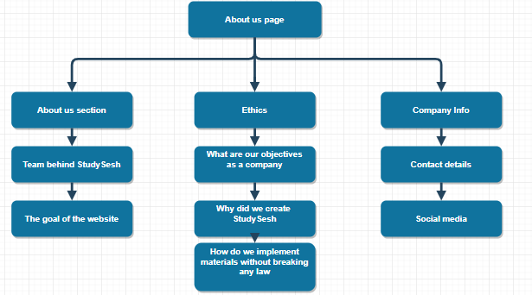

Later on in the project after I created the homepage, I decided to start designing the about us page. For this task I created a flowchart for the structure of the page. This initial flowchart was the best I came up with as it explains thoroughly the main components of the page in each section.

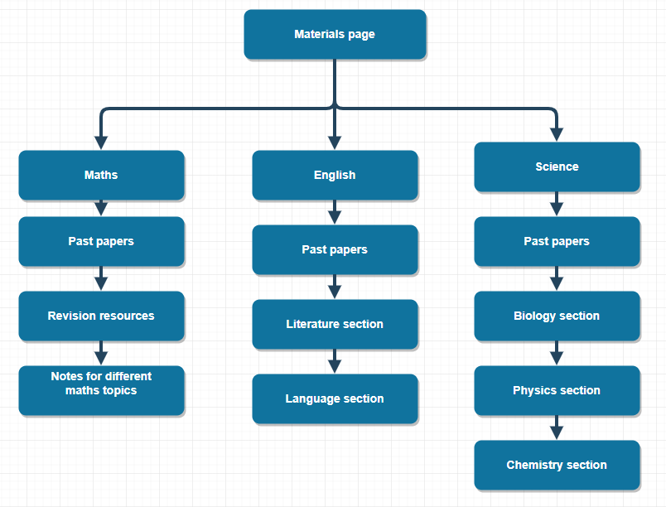

After I designed and built the about us page, I proceeded to create a flowchart for the material page. On this flowchart I tried to structure how the page it’s going to be linked to its subpages (Maths, English and science) and also the type of content that those subpages are going to contain. The finished flowchart was very detailed and very good explained so I decided to build the Materials page around it.

# Choice of Programming Languages

One of the most integral aspects of web development is web programming that is achieved with the help of programming languages. Web development languages are the platforms through which instructions are communicated to a machine and actions are pursued. The main programming languages that I chose to create my program are:

* HTML - this is the scripting language of the web used to define structure of a website.
* CSS - this is the design and layout language used on the web to turn your website from an empty frame into something pretty and well laid out.
* JavaScript/ jQuery - this adds animations, or improved user experience elements to your website. Sliders, menu navigation, animations, etc. will require JavaScript. You can also use jQuery which is a library built on top of JavaScript to make a few things easier.
* Bootstrap - is a framework to help you design websites faster and easier. It includes HTML and CSS based design templates for buttons, navigation, image carousels, etc. It also gives you support for JavaScript plugins.

# Choice of the Text Editor

Choosing a good text editor makes a big difference on many parts of the project, such as: efficiency when writing code, compatibility of the program and make programming easier by autocompleting repeating code. This are some of the text editors that are famous for their quality and performance:

* Sublime-Text: Its interface is friendly, so it is easy to use, it has a very good number of keyboard shortcuts that allows me to quickly access any program complement or perform any operation. This helps programmers to be more efficient when writing code.
* Atom: atom is a free to use text editor that’s very beginner friendly. It has a lot of features that help users to write code such as integrated Developer Tools and Ui that’s easy to customize. This text editor is also well connected to GitHub, the platform that I use in order to organise myself when doing computer science project.

For this project I chose to use Atom as my preferred text editor as it proves to be very useful and reliable when writing code, but also very easy to use.

# Ideas for the name of the Website

When choosing a website name, a business has to be very careful by what the name represents, as they won’t be able to change it in the future. The name of the website is also required to be simple and good looking, so when a user sees it in another website, he/she will be incited to click on the link.

As the website is based on GCSE revision and is focused to young audiences, it means that the name of the website must contain some words that are familiar to teens. I chose this approach as younger audiences are usually more attracted to things that they find relatable.

Some of the names that I came up with were:

* MasterGCSE: I considered this name inappropriate for the website as it was both too long and not very relatable to the target audience
* RevSite: It was a name combined from a mixture of ‘Revision’ and ‘Site’.
* StudySesh: It’s a combination of the words ‘Study’ and ‘Sesh’ (sesh is an abbreviation of the word session). This name is very concise and uses language that is common between teenagers, which makes it more relatable.

# Choice of the website’s base colours

As mentioned in my ‘Website project brief’ under the exemplar websites topics, the main colours that I was aiming to use in this website would be predominantly whiter colours, as they are associated with a modern look. I also added other colours such as blue and black, so the website wouldn’t look too simple. A small mix of colours also adds a sense of variety that users can associate with. When combining them, I also had to make sure that they weren’t obstructing colour-blind users from navigating the page, as the user experience is of great importance for the success of a website.

# Choice for the main font of the website.

Choosing the main font for your website is usually one of the most important choices a web-developer can make. Text in a website should look approachable to the user and somehow look familiar to him, so that he may be inclined to read it. Moreover, the size of the font also depends on the type of heading of the text. For example, a main heading can’t have the same size as the paragraph following it, it just doesn’t look right for the user. Therefore, when selecting the fonts I need to decide the size of the fonts to use for the headings and the paragraphs.

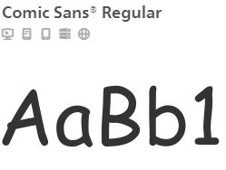Font discussion:

At the beginning of the project I decided to use the ‘comic-sans’ font for all the text because it was a font that is very familiar to my target audience. I also chose this font because it was very easy to implement in the website.

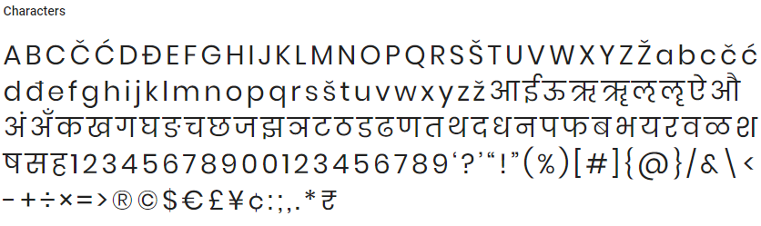

Later on in the project I decided to change the main font to ‘poppins sans-serif’. I decided to change to this font because I though that the ‘comic sans’ font looked to childish in the website and didn’t completely suit my target audience.

Size discussion:

For the paragraphs of text I decided to use the paragraph section in HTML (which looks like this: <p></p>). This code allows me to resize a specific part of text. I used this across all of the pages when I tried to add text to the website in order to maintain a consistent size for the website. 

The code above shows an example of how the paragraph section in HTML is used. In this exaple the text in white will be displayed in the webite at a small font size, which is the optimal solution. On the other hand, for headlines I used the Headline section offered again by HTML (looks like this <h1></h1>). This code increases the size of the text and the level of boldness depending on the number used inside the brackets (numbers between 1 to 8 can be used).

The line of code above will make the white text be increase in both size and boldness. This will make the text look more like a headline to the user, which is the intended solution.

# Content requirements

The content is the heart of a website. For the page to be successful it needs content that is up to standards and attracts the audience that you are targeting. Through research I concluded that the content of my website must follow these rules:

* The content has to appeal to teenagers.
* The website should have a low amount of text for the user to read.
* It should contain animations and special effects.
* Advertising is allowed but should be kept to a minimum.

By meeting these requirements, I’m adapting the website to the audience demands.

# Choice of images for the Homepage

When choosing images for the website I have to be very careful that I don’t make any copyright infringement, which basically means that I can’t use images that are copyrighted by other authors. Therefore I will have to create most of the images used in my website to avoid any copyright issues.

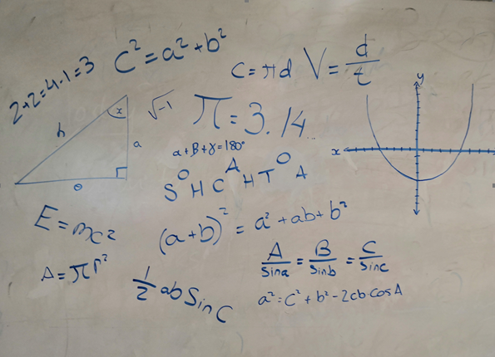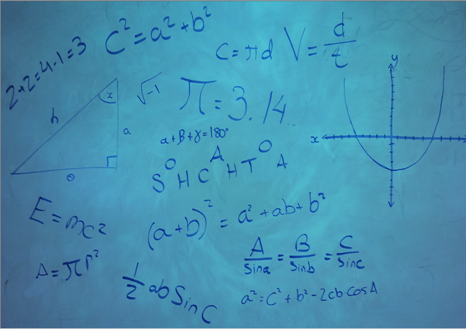The first image that the user can see when entering the website is the carousel image that has many equations and graphs in it. I designed this image in a classroom’ board by drawing random equations in it. I then took a photo of it (image in the right), and then proceeded to Photoshop it to make it look more attractive. The final result is the image to the left, where blue is the dominant colour, as blue is one of the main colours of the website.

When scrolling down in the homepage this image will show up under the ‘Meet the Creator’ Section, followed up by some information. I was sceptical at first in whether to put my image into the website or not. At the end I decided that adding my image will make the website more authentical, as it’s not a stock photo of a random person. I also used this image in the about us page under the same section

# J:\Extended Project\Classes\Level 3 Extended Project D2\elanzavalenciano17\Extended-project\Extended-project-v.2-master\Website Files\img\english1.pngChoice of images for the Materials Page

Choosing images for this page was very difficult and challenging as I had to comply with copyright laws to the best of my ability. For this page I was searching for icons that represented the 3 different core subjects and that were colourful at the same time.

For this type of request I went to a stock-photos provider’s website in order to search for icon that didn’t have any copyright.

In there I found these three icons that were made by the same person that stated that its icons were copyright free. I thought they were perfect for my website as they were of different colours and also contained an item that is unique to its subject.

# Choice of images for the About us page



For the about us page I reused my image in the ‘meet the creator’ section in the homepage. I did this so that the website has consistency across all pages. Nevertheless, for the ‘About StudySesh’ section I used the image in the right. I chose this image for this section as it suit the colours of the website, as they are very light and subtle. The image itself is also very minimalist which is a recurrent topic in my website and it also suits my target audience’s requirements as it doesn’t contain any unnecessary information. This photo also symbolises the simplicity yet beautiful design of the website, as in the photo we can see that only the basic school materials are used, but they are so well placed that it makes the image look very satisfying.

# Logo of the website

A logo is an important part of your company's brand, and makes a significant impact on a company's public perception. In fact, a logo is one of the most important branding investments a business can make. A logo can be described as the face of a company.

For this reason I dedicated a lot of time and effort to create a logo that is relatable to students and attracts their attention when looking at it.

For the design of the main logo I created a big letter S that had a bold letter S inside of it in order to symbolise that the two initials in the name of the website, StudySesh. After designing this in Photoshop I added the name of the website on its right because the S alone looked too simple and not very attractive. This way the user knows what the symbolisms of the big S tries to portray.

Evaluation and Conclusion

This project has allowed me to explore a topic of great interest for me, and helped me gain extensive knowledge on the website programming and designing areas. I also improved a wide variety of skills with this EPQ that will help me on my further education, such as: time management, the production of quality research and presentation skills. As a prospective Computer Science university student, this type of skills are of immense help when facing such a mathematical subject. Time management skill is the most important as in most degrees, coursework always has a deadline that must be met in order for it to be accepted, therefore making this skill crucial for further education.

By doing this project I have also learned many front-end programming languages such as HTML, CSS and Bootstrap, as well as JavaScript (a back-end language). I gained experience in these languages by doing different types of courses in SoloLearn, which helped me learn the basics and some of the intermediary level material. Having this type of experience in these languages has helped me develop my problem-solving skills as well as my web developer background, which will boost my university application, as they are usually searching for experienced programmers to add to their Computer Science courses.

The original client brief stated that the website has to be both attractive to teenagers and designed with a budget of £0, but should also create a revenue stream via a 3rd party shop or advertisement. When it comes to making a website attractive to such a young generation, I had to do a considerable amount of research in order to get an idea of what GenZ audiences were looking for. For this type of research I used various articles and website which were very thorough and detailed on the process of designing a website, and helped me understand the techniques required to retain users into my page. The second objective of the client required me to create the website without having any type of cost. That means I had to create all of my materials and decoration, as I couldn’t buy them from anyone, and then launch the website in a free hosting service. I successfully managed to fully design and create the website without the need to spend any money as I produced all the content by myself, while also using materials from other websites by using links to redirect the user to them. This strategy allowed me to stay within the client’s budget while also including enough content for the users.

I created my presentation on Prezi, a presentation software website. I used photos from both my research and development section and also information from my project brief in order to provide up to date information and to help me with illustration. Before doing this presentation, I did extensive research on how to do a good presentation and the factors that are of most importance.

From this research I obtained various tips that I used while doing the presentation, such as: maintaining eye contact with the audience, ask rhetorical questions and to move around while explaining or showing the slides so the presentation is not boring. I think that all of these tips helped me do a successful presentation as I had great feedback from fellow students, as well as many questions from the audience which shows that the presentation was engaging.

While doing this project one of my main strengths was the ability to research and learn the different programming languages that were required to build a website. Being already knowledgeable on this topic also helped me understand the logic behind designing websites, which reduced the time needed to learn the different programming languages. On the other hand, a small weakness of my performance in this project was the time management while building the website. Looking back into what I did, I think I should have spent more time trying to add more subjects into the website, instead of attempting to add monetisation to the website. Nevertheless, if I was to do this project again I would make a project plan in order to organise my time in a more efficient way so my website can have more subjects. In conclusion, I think this project has been a clear success when talking about its performance and the personal development I obtained out of it, as it allowed me to increase my expertise in an area of interest.

This project has a substantial amount of potential to be a successful website if launched properly under a healthy budget. Nevertheless, much more work should be put in the website before anything can happen. More subjects should be added so the website is useful to more people and therefore engaging a bigger audience and also a monetisation scheme should be put into place in order to gain money from the website. Once this and another minor fixes are completed, this website could grow to be helpful and lucrative, which is the main goal of any web developer.

Along this project I faced many difficulties that could have been avoided if I just knew before doing anything. A piece of advice for future students would be to never underestimate the time that you have while doing this project because this type of work can’t be rushed, as if you do, it will end up not being of good enough quality. Another tip would be to begin this project with a clear plan. I did this at the beginning of my project; it helped me a lot to have deadlines that I had set myself specifying what work must be done before a set date.

Undertaking the EPQ has brought me an immense amount of new skills, as well as improve other ones in which I had a weaknesses on. This allowed me to develop myself both as an individual and as a web-developer, which will help later in my career when applying to Universities or to jobs. I am also very grateful for this opportunity as it helped me understand my strengths as a programmer and also helped me grow my web-developing experience.

Presentation Slides

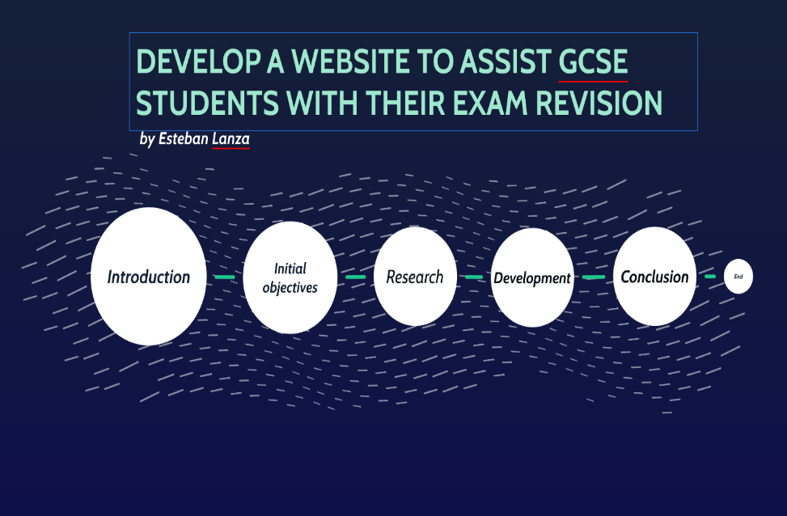

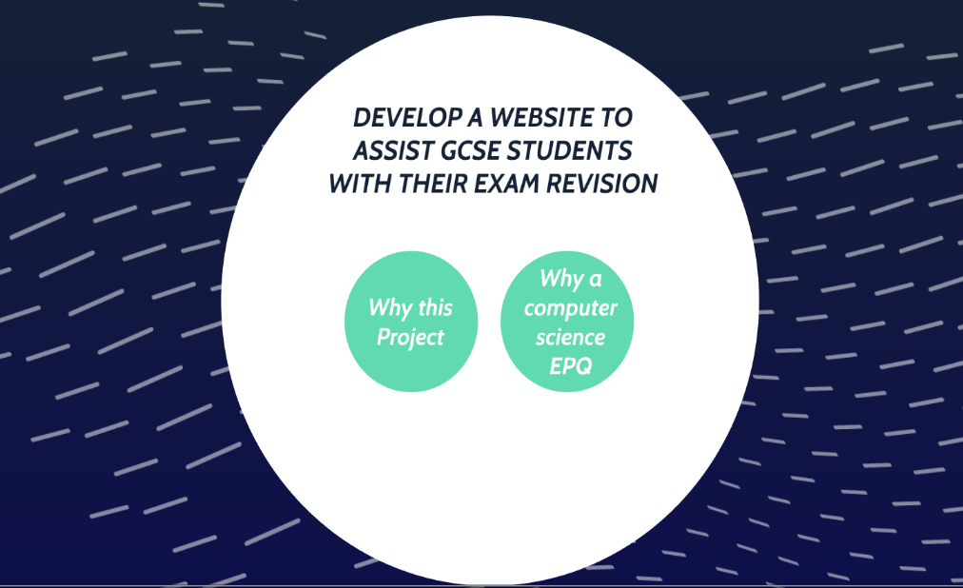

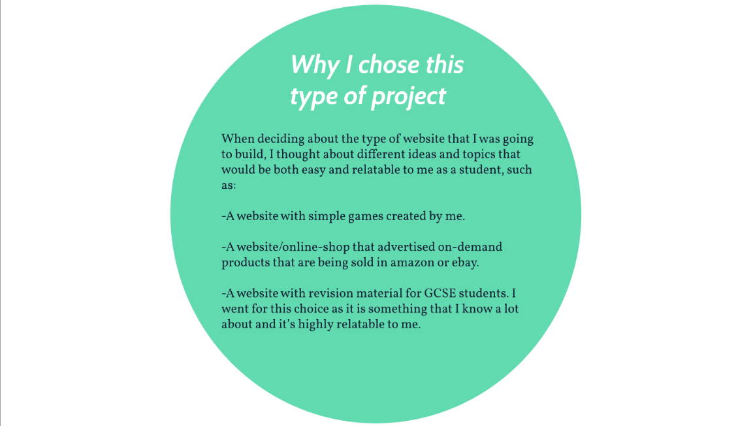

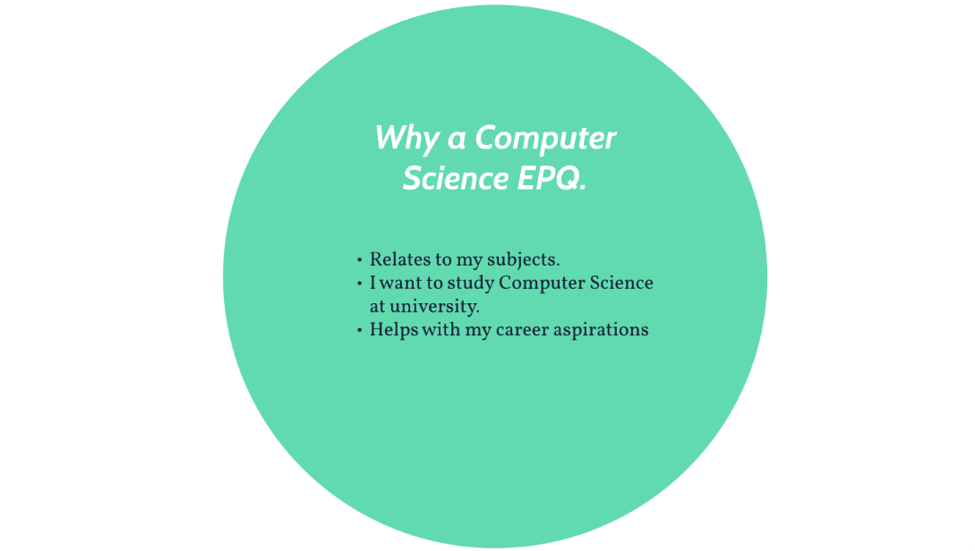

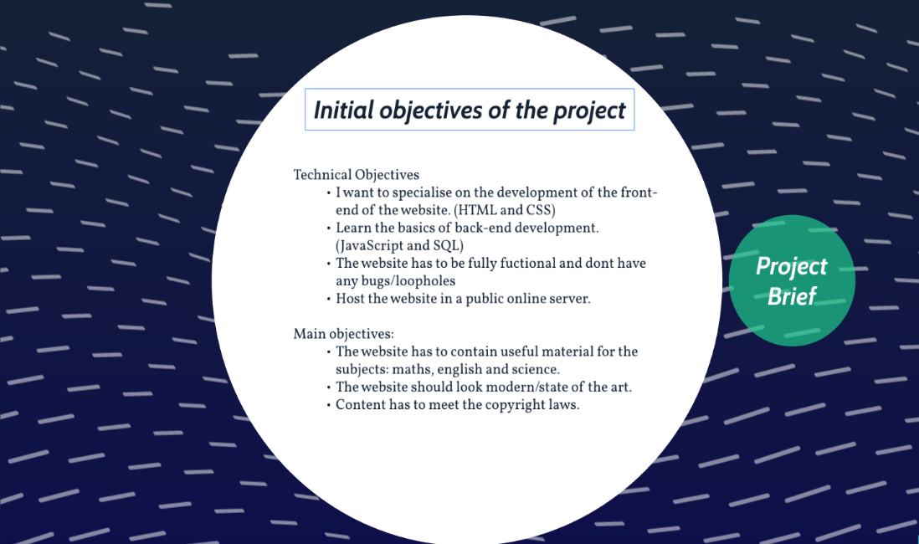

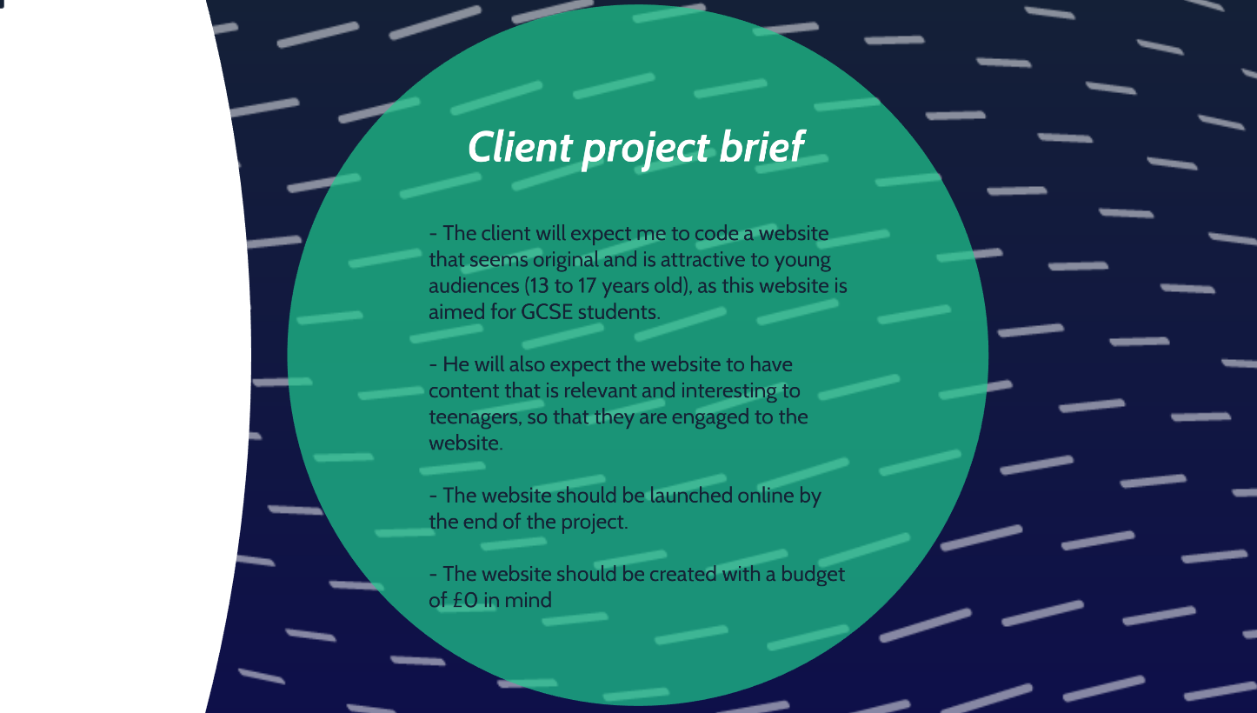

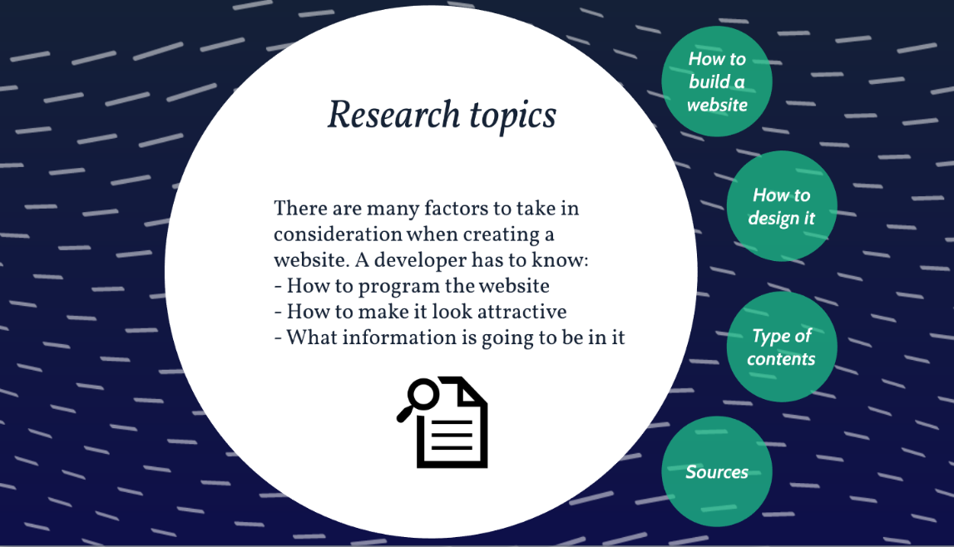

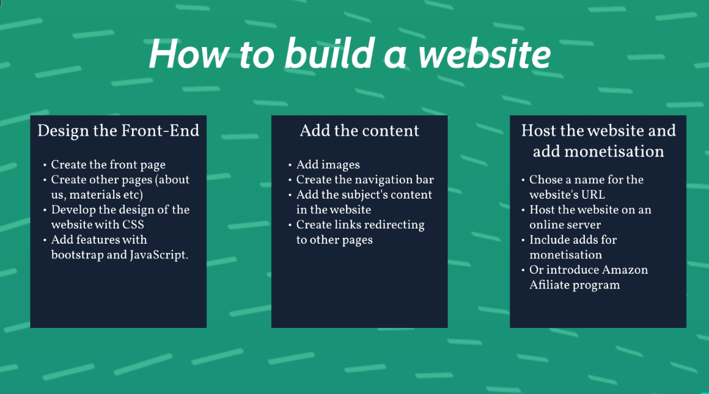

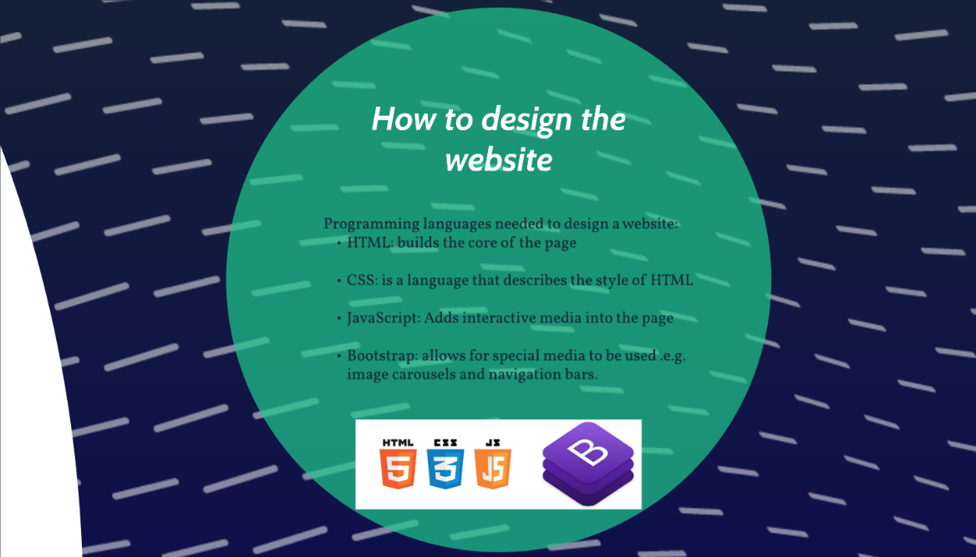

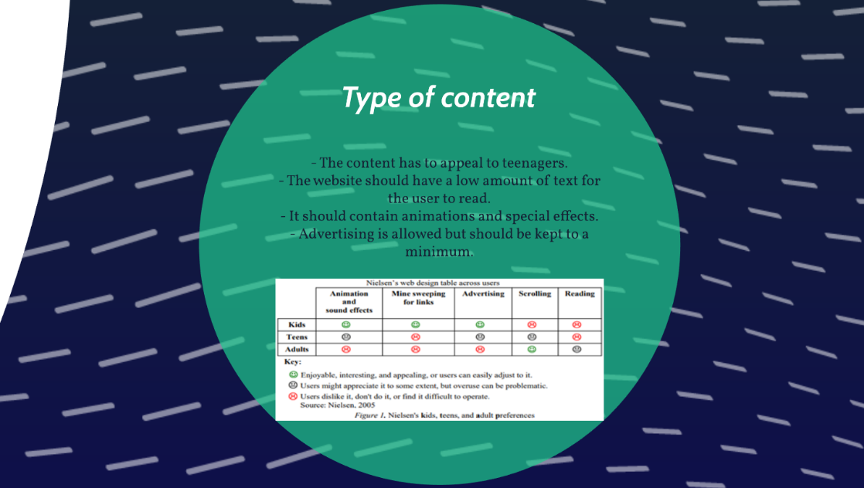

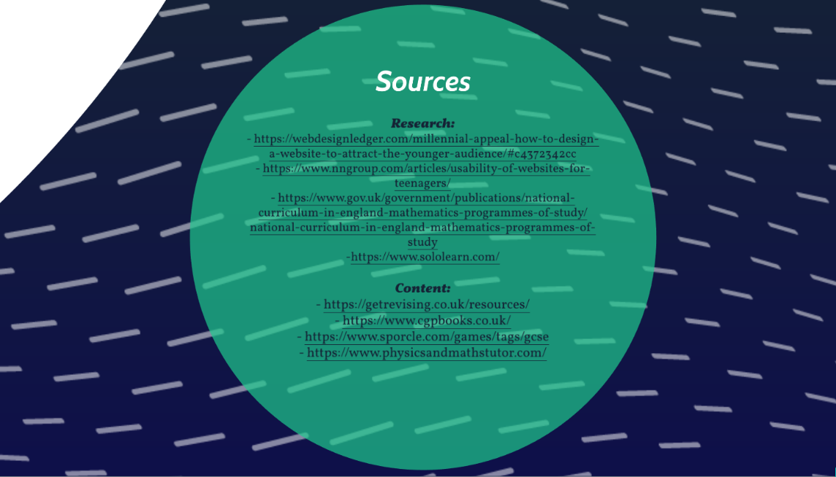

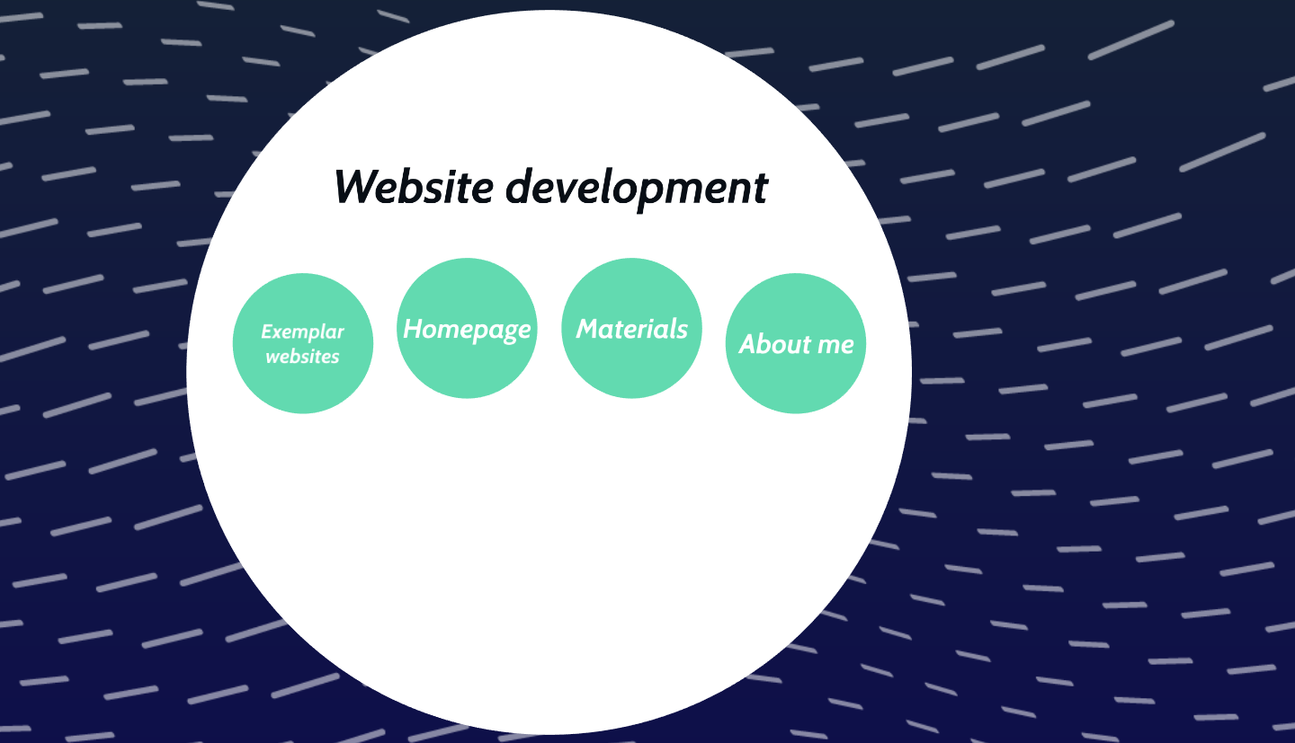

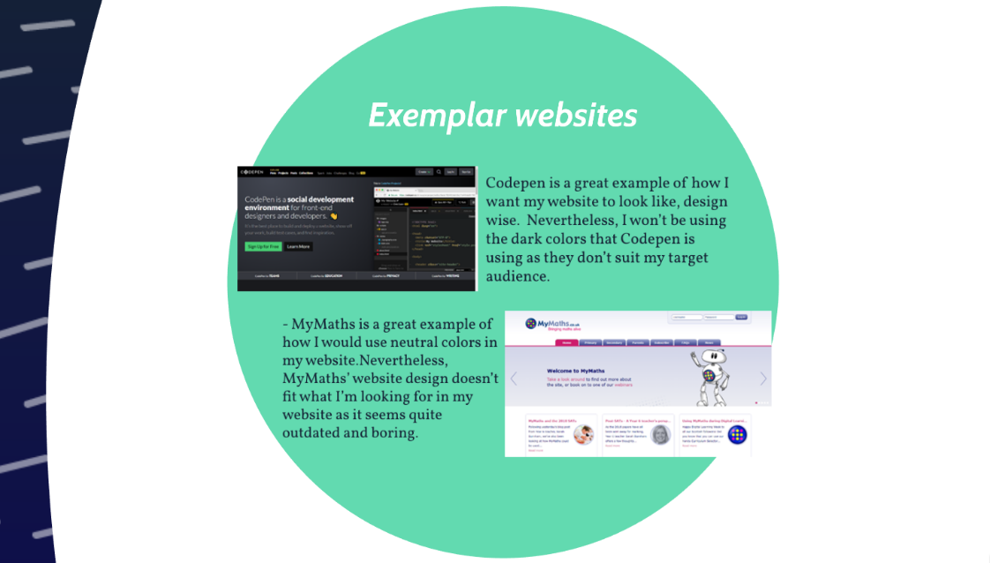

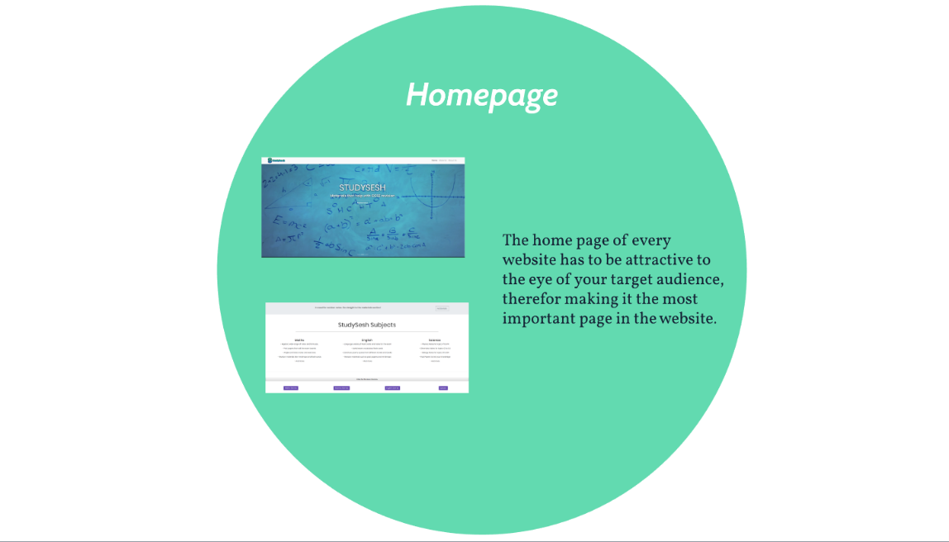

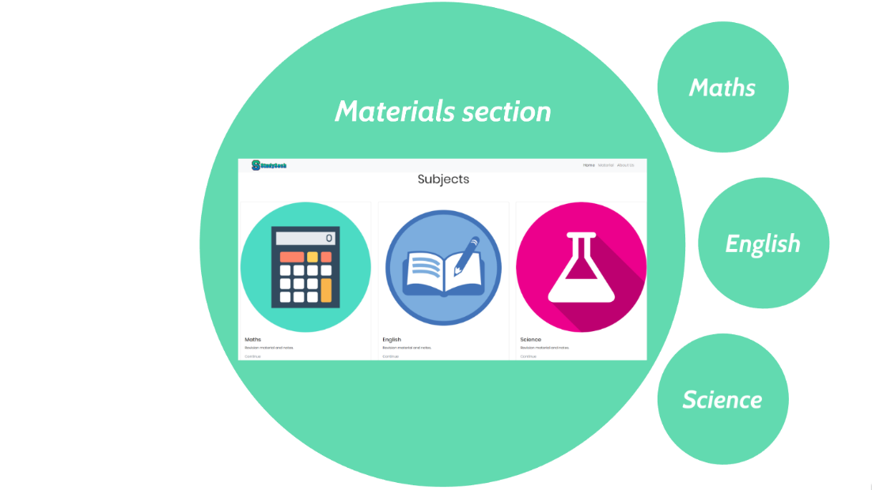

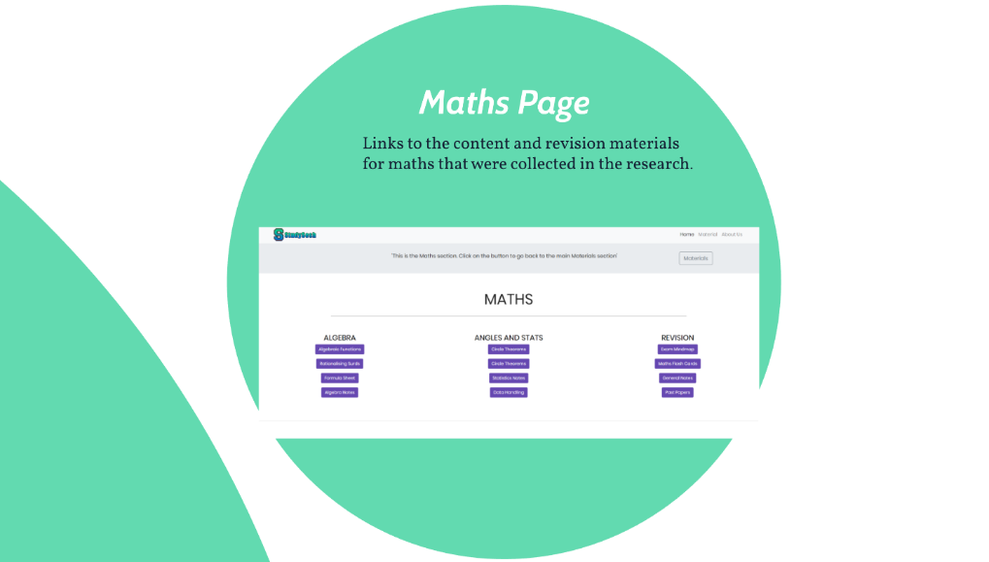

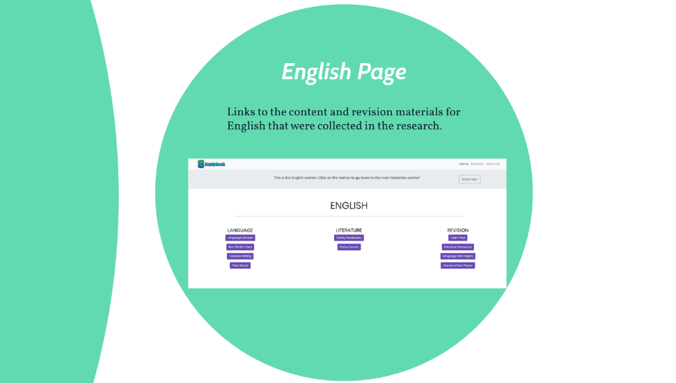

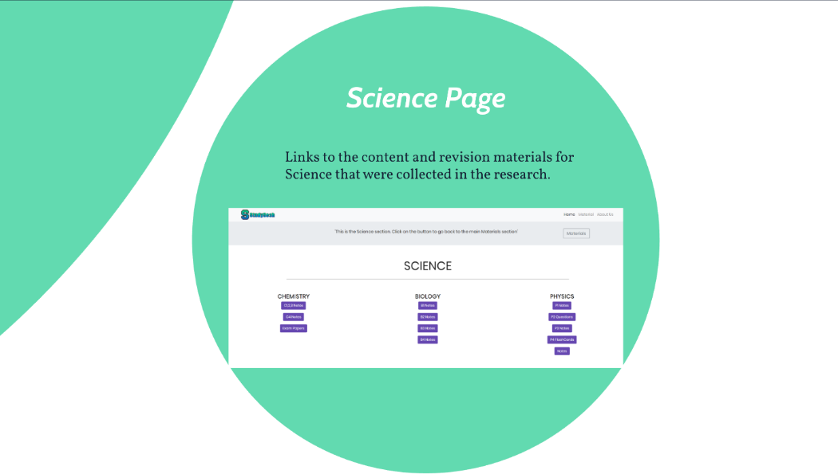

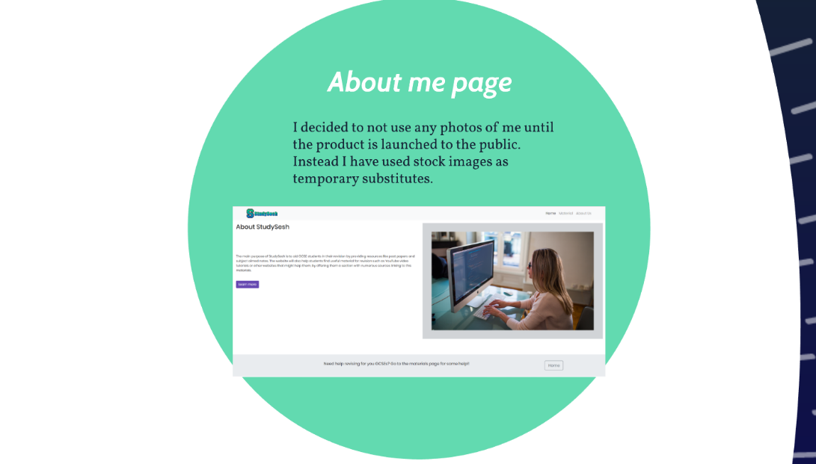

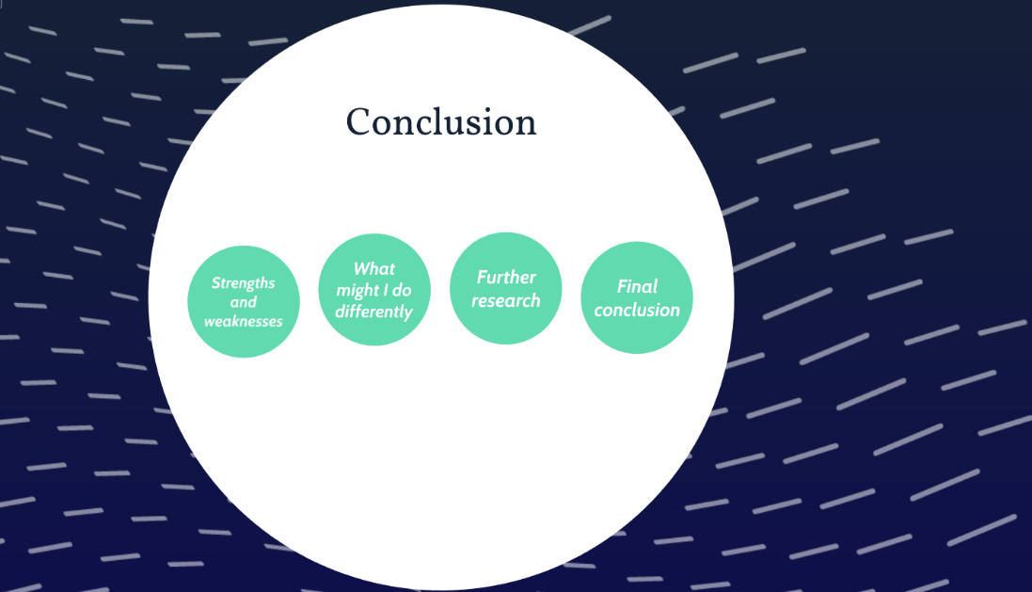

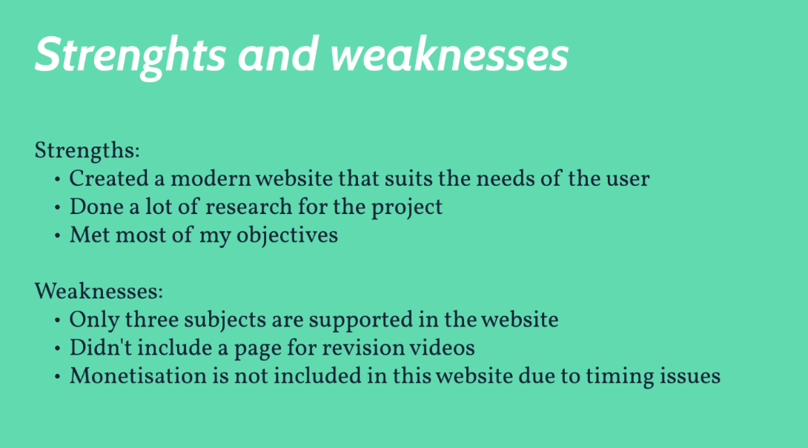

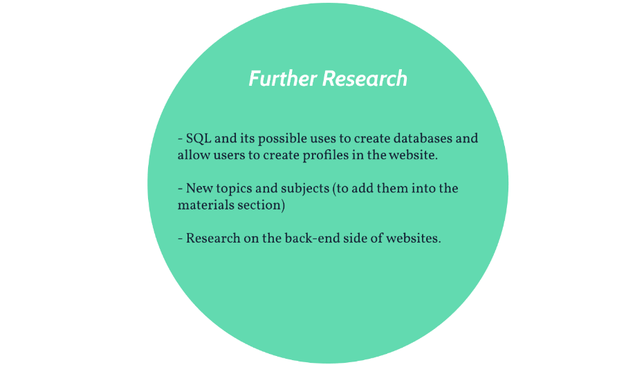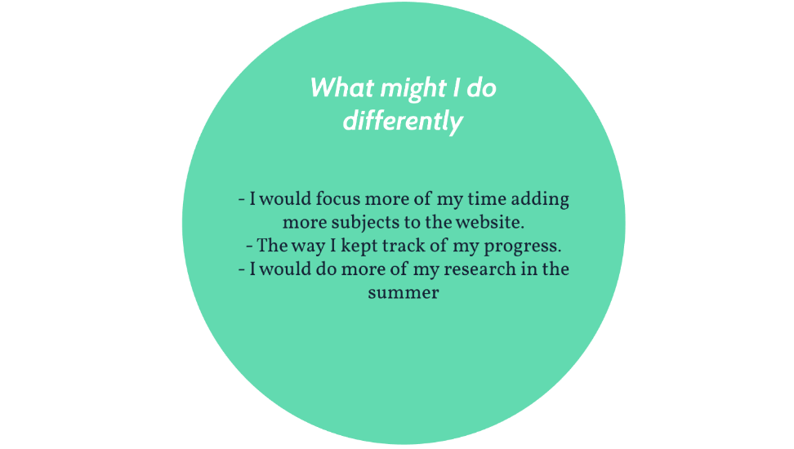

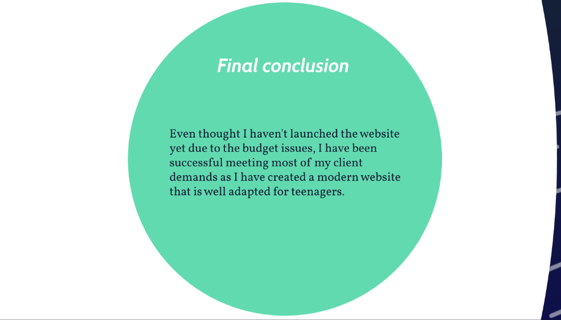

|  |  |  |  |  |  |  |
| --- | --- | --- | --- | --- | --- | --- |
| Activity Log form | | | | | | |
| Learner Name | Esteban Lanza | |  | Learner number | 1091649021 |
|  |  | | |  | |
| Centre Name | Peter Symonds College | |  | Centre Number | 58281 |
|  |  | | |  | |
| Teacher Assessor | Sam Holmes | |  | Date | 24/09/2018 |
|  |  | | |  | |
| Unit | Artefact – P304 | |  |  | |
|  |  | | |  | |
| Proposed project title | | Develop a website to assist GCSE students with their exam revision | | | |

|  |  |  |
| --- | --- | --- |
| DATE | HOURS | DESCRIPTION |
| *Beginning of the project* | | |
| 12/06/2018 | 1 | Class: introduction to the extended project |
| 17/06/2018 | 1 | Research: the structure of a website.  Class: created a flowchart of the homepage of the website for organization |
| 20/06/2018 | 2 | Practical: Started a SoloLearn course of basic HTML. |
| 21/06/2018 | 1 | Practical: Started a SoloLearn course of CSS and JavaScript. |
| 24/06/2018 | 1 | Research: Watched YouTube videos on how websites are created by using code, and how they are hosted. |
| 26/06/2018 | 1 | Class: started to make the website project brief. |
| 28/06/2018 | 1 | Class: finished the project brief.  Started research on website development of graphical design |
| 30/06/2018 | 2 | Practical: created a flowchart for the about me page  Practical: created a flowchart for the materials page |
| 03/07/2018 | 1 | Class: information given by librarians of pages we can get research from.  Class: tried out CREDO reference. |
| 10/07/2018 | 1 | Class: did a to-do list for the summer |
| *Summer holidays* | | |
| 15/07/2018 | 2 | Research: Created a name for the website that was suitable for the content of my website.  Research on how to make websites more attractive to teenagers. |
| 18/07/2018 | 2 | I did more research on how to make a website more attractive to teens but instead of looking in websites I used credo to find journals to increment the credibility of my research.  Incremented the number of sources used in research. |
| 26/07/2018 | 3 | Practical: practised coding HTML and CSS in the SoloLearn page.  I completed the course of HTML, which increased my skills as a website developer. |
| 31/07/2018 | 1 | Practical: Created the homepage layout. I obtained help from videos in YouTube and tutorials. |
| 10/08/2018 | 2 | Practical: Created the about me layout. I also did a draft of the ethics page layout although I’m not sure is going to be added to the final website. |
| 15/08/2018 | 1 | Updated the sources form to include all the websites and journals I have used for my research |
| 18/08/2018 | 2 | Theory: Started to work on my project proposal form.  Research: watch video tutorials about graphical design in photoshop. This led me to install photoshop for further use. |
| 25/08/2018 | 4 | Practical: Use the templates of the ‘homepage’ and the ‘about me’ pages to create the semi-finished version of the pages, as graphical work still needs to be implemented.  Research: learned how to use bootstrap to implement it in my website so it’s more accessible for mobile users. |
| 01/09/2018 | 2 | Practical: implemented bootstrap code in both of the pages I created in late-august. |
| Beginning of Upper Sixth year | | |
| 06/09/2018 | 2 | Research: client told me that he wanted to monetize his website. I did some research on how companies monetize website without ads. Came across Amazon affiliate program. Investigated how this could benefit my website and saw tutorials on how to implement it. |
| 11/09/2018 | 1 | Class: created a flowchart for the shop page. |
| 13/09/2018 | 1 | Class: Created a flowchart for the materials page |
| 16/09/2018 | 2 | Theory: kept working of my project proposal form  Practical: created a logo for the website. |
| 18/09/2018 | 1 | Class: finished the project proposal form. |
| 20/09/2018 | 1 | Research: started to do research on how to implement material like past papers and notes without copyright laws interfering. |
| 25/09/2018 | 1 | Class: updated and finished the materials and shop flowcharts.  Class: Started the Research Review document, and started to work on it with the research I did on the summer. |
| 01/10/2018 | 1 | Class: Created the background for the website so I don’t violate any copyright issues. I made it by drawing mathematical equations in a whiteboard. |
| 09/10/2018 | 1 | Class: Selected Maths resources from websites to include in my materials section of the website. Most of the resources are for the algebra topic, but I still need to cover more topics. |
| Half Term | | |
| 12/10/2018 | 2 | Research: I went online to find useful websites that had rich GCSE content that I could link to in my own website. I did this because, due to copyright issues, I can’t use their content in my website without their permission. But if I link their content in my website, then based on my research, it should be within the law to use their content. |
| 13/10/2018 | 3 | Research: Found out that GetRevising and MathsAndPhysicsTutor are great for outsourcing GCSE material from their websites.  Research: Extracted Maths and English materials, such as flowcharts and notes, from both websites. |
| 15/10/2018 | 1 | Research: Extracted Science materials, such as past papers and notes, from both websites. |
| 16/10/2018 | 4 | Practical: Created a new page for my website called ‘Materials’ which holds the links to the sections ‘Maths’, ’English’ and ’Science’.  Practical: Alsco created three new pages for the subjects. After the pages were created and set up, I then proceeded to implement buttons that will link the materials (mind maps, notes etc) to the website. |
| 17/10/2018 | 2 | Practical: Updated the information within the website like the ‘about me’ page info and also some of the ‘Home’ info.  Practical: Joined the pages together so the navigation bar works as intended and allows the user to navigate the website without getting stuck in a loop or a dead end. |
| 20/10/2018 | 1 | Updated both the Activity Log and the Sources documents in order to keep track of my progress. |
| 23/10/2018 | 1 | Class: I improved the Activity log in order to keep up with all the progress that I’m doing in the project. I also created a new ‘sources’ document to help me keep track of my sources easier. |
| 30/10/2018 | 1 | Class: had a talk on how to do the presentation. I did further research on good presentation skills and began setting up the plan for my presentation. |
| 01/11/2018 | 1 | Class: added links that redirect the user to the resources, depending on the subject. After all the links were places in the Subject Pages (Maths, English and science), I updated the sources log so that all the links are stored and explained. |
| 06/11/2018 | 1 | Class: After investigating the different ways to create the presentation I chose Prezi as the presentation software that I was going to use. |
| 08/11/2018 | 1 | Class: Started creating the presentation in Prezi. I designed the structure of the presentation by looking at past students’ presentations to get an idea of what a good, well-structured presentation looks like. |
| 10/11/2018 | 2 | Practical: added a text to the about us page which explains the different goals and objectives of StudySesh. It also explains the reason for its creation and shows the website’s programmer. |
| 13/11/2018 | 1 | Class: in this class I checked for spelling mistakes within the website. Due to the website not having much text within it (everything being mostly in the about us page), I didn’t find any spelling mistakes. |
| 17/11/2018 | 3 | Practical: I completely created the presentation that needs to be perform on the 29th of November. I took different parts of my research and the projects brief to add relevant information to the presentation slides, to save time and to generate a presentation with accurate information that I have seen before, which helps when explaining it to others on presentation day. |
| 21/11/2018 | 1 | Practical: Practiced the presentation in front of my family and used the feedback to further improve my presentation slides and to enhance my presentation skills. |
| 22/11/2018 | 1 | Class: I began and completed the abstract for the project. This took longer than expected as I wanted it to be perfect, as the abstract is the first thing the reader sees at the start of my project. |
| 27/11/2018 | 1 | Class: improved the presentation using the feedback received from both classmates and friends. I did some changes to the structure of my presentation and deleted some slides that didn’t fit with the purpose of my presentation. |
| 29/11/2018 | 1 | Class: did my presentation in front of an audience. Even though I faced minor technical difficulties (pc shutdown randomly), I successfully conveyed my project’s topic. |
| 02/12/2018 | 2 | Practical: I wrote the evaluation and conclusion section of the project. I reflected back on what I improved in personally and also what I could do better next time. |
| 04/12/2018 | 1 | Class: days after the presentation, I took notes of how I think I did and also what I think I should have improved. With these notes I wrote a small evaluation of how I performed in the presentation. |
| 06/12/2018 | 1 | Class: I received feedback regarding the state of my website and how it can be slightly improved to better fit my target audience. Suggested changes to the font and colours of my website, as well as the possibility of increasing the number of images in it. |
| 08/12/2018 | 4 | Practical: I proceeded to make the final changes to the website based on the feedback received from the last class. I made some adjustments to a few colours of the website. I also changed the font of some of the texts depending on their position within the page in order to close out any gaps and blank spaces. |
| 11/12/2018 | 1 | Class: recorded all the changes made on the website in the development section of the project. |
| 13/12/2018 | 1 | Class: Went through the whole project to double check for spelling mistakes and to improve anything that need further improvement. Made screenshots of the presentation and pasted them into a word document. Prepared all the documents and join them as one for printing. |

# Evaluation of sources

## **Research Sources**

|  |  |  |  |
| --- | --- | --- | --- |
| Resource and Title | Author, edition, publisher, date, URL | Reliability | Information gained/Usefulness |
| Website article - Millennial Appeal: How to Design a Website to Attract the Younger Audience | John stone -  <https://webdesignledger.com/millennial-appeal-how-to-design-a-website-to-attract-the-younger-audience/#c4372342cc> | This article has low reliability as its just from as his is just a writer with one article in the website, which proves he is inexperienced | Attributes that a website needs in order to attract a young audience. |
| Website Article -  Teenage Usability: Designing Teen-Targeted Websites | Hoa Loranger and Jakob Nielsen -  <https://www.nngroup.com/articles/usability-of-websites-for-teenagers/> | The article is considered of high reliability as is being written by experts on the field with many years of research on this topic | Explanation of the stereotypes of the Z generation, and what are they searching for in a website. |
| Resource - National curriculum for maths | <https://www.gov.uk/government/publications/national-curriculum-in-england-mathematics-programmes-of-study/national-curriculum-in-england-mathematics-programmes-of-study> | This resource was created by the government to dictate the maths curriculum. | What materials do I need to include in my website to enable students to have the maximum help possible. |
| Resource - National curriculum for English | https://www.gov.uk/government/publications/national-curriculum-in-england-english-programmes-of-study/national-curriculum-in-england-english-programmes-of-study#key-stage-4 | This resource was created by the government to dictate the English curriculum. | What materials do I need to include in my website to enable students to have the maximum help possible. |
| Resource - National curriculum for science | https://www.gov.uk/government/publications/national-curriculum-in-england-science-programmes-of-study/national-curriculum-in-england-science-programmes-of-study#key-stage-4 | This resource was created by the government to dictate the Science curriculum. | What materials do I need to include in my website to enable students to have the maximum help possible. |
| Webpage – SoloLearn | https://www.sololearn.com/ | This webpage has high reliability, as the resources the offer are created by professionals. | Learned how to program HTML, CSS and the basic of the library Bootstrap. |

## Maths Material Sources

|  |  |  |  |
| --- | --- | --- | --- |
| Type of resource | URL | Content | Topic covered |
| Video | <https://getrevising.co.uk/resources/algebraic_fractions_lesson_maths_a_gcse1> | Algebraic functions | Algebra |
| Video | <https://getrevising.co.uk/resources/rationalising_surds> | Rationalising Surds | Algebra |
| Mindmap | <https://getrevising.co.uk/diagrams/maths_mock_revision> | Mock Revision | All |
| Notes | <https://getrevising.co.uk/diagrams/maths_mock_revision> | Exam Revision | All |
| Mindmap | <https://getrevising.co.uk/diagrams/maths_formulas_and_uses> | Formula sheet | Formulas |
| Notes | <https://getrevising.co.uk/revision-notes/mathematics_algebra_formulas_and_equations> | Algebra revision | Algebra |
| Flashcards | <https://getrevising.co.uk/revision-tests/maths-general-rules-formulas-and-equations?game_type=flashcards> | General | All |
| Notes | <https://getrevising.co.uk/resources/gcse-maths-revision> | General | All |
| Info cards | <https://getrevising.co.uk/revision-cards/circle-theorems-11> | Circle theorems | Angles |
| Powerpoint | <https://getrevising.co.uk/resources/circle_theroms_stuff> | Circle theorems | Angles |
| Mindmap | <https://getrevising.co.uk/diagrams/maths_statistics_1_continued> | Statistics summary | Statistics |
| Notes | <https://getrevising.co.uk/revision-notes/finding_the_mean_mode_median_and_range> | Data Handling | Statistics |
| Past Papers | <https://www.physicsandmathstutor.com/past-papers/gcse-maths/> | General | All |
| Games | http://www.bbc.co.uk/schools/gcsebitesize/games/rurevising/maths.shtml | General | All |
| Quizzes | https://www.sporcle.com/games/tags/gcse | General | All |

## English Material Sources

|  |  |  |  |
| --- | --- | --- | --- |
| Type of resource | URL | Content | Topic covered |
| Exam Prep | <https://getrevising.co.uk/revision-notes/gcse-english-language-paper-1-explorations-in> | Creative writing | Language |
| Exam Prep | <https://getrevising.co.uk/revision-cards/reading_non_fiction> | Non Fiction texts | Language |
| Mindmap | <https://getrevising.co.uk/diagrams/language-devices-81> | Language devices | Language |
| Flash cards | <https://getrevising.co.uk/revision-tests/a_vocabulary_english_language?game_type=flashcards> | Vocabulary | Language |
| Notes | <https://getrevising.co.uk/revision-notes/peed> | Exam Prep | Language |
| Flash cards | <https://getrevising.co.uk/revision-tests/english-poetry-terms?game_type=flashcards> | Poetry Vocabulary | Literature |
| Past Papers | https://getrevising.co.uk/past-papers/search?level=gcse&subject=english_language&board= | Exam papers | Language |
| Past Papers | https://getrevising.co.uk/past-papers/search?level=gcse&subject=english_literature&board= | Exam papers | Literature |
| Flash cards | <https://getrevising.co.uk/revision-cards/aqa-love-and-relationships-poetry-quotes> | Quotes | Literature |
| General | <https://getrevising.co.uk/resources?q=&level_id%5B%5D=gcse&subject_id%5B%5D=english_literature> | General | General |
| Exam Papers | <https://www.physicsandmathstutor.com/past-papers/gcse-english-language/> | General | Language |
| Exam Papers | <https://www.physicsandmathstutor.com/past-papers/gcse-english-literature/> | General | Literature |
| Games | http://www.bbc.co.uk/schools/gcsebitesize/games/rurevising/english.shtml | General | All |
| Quizzes | https://www.sporcle.com/games/tags/gcse | General | All |

## Science Material Sources

|  |  |  |  |
| --- | --- | --- | --- |
| Type of resource | URL | Content | Topic covered |
| Notes | <https://getrevising.co.uk/revision-notes/ocr_21st_century_b2> | Topic B1 | Biology |
| Notes | <https://getrevising.co.uk/revision-notes/ocr_21st_century_b2> | Topic B2 | Biology |
| Notes | <https://getrevising.co.uk/revision-notes/b3_revision_notes_2> | Topic B3 | Biology |
| Notes | <https://getrevising.co.uk/revision-cards/b4_28> | Topic B4 | Biology |
| Notes | <https://getrevising.co.uk/resources/ocr_21st_century_science_a_c1_c2_c3_revision_notes> | Topic C1 C2 C3 | Chemistry |
| Notes | <https://getrevising.co.uk/revision-cards/chemistry_c4_2> | Topic C4 | Chemistry |
| Notes | <https://getrevising.co.uk/resources/aqa_additional_science_physics_revision> | General | Physics |
| Prep Questions | <https://getrevising.co.uk/resources/gcse_additional_physics_p2_revision_booklet> | Topic P2 | Physics |
| Notes | <https://getrevising.co.uk/revision-cards/p1_8> | Topic P1 | Physics |
| Notes | <https://getrevising.co.uk/revision-cards/p3_12> | Topic P3 | Physics |
| Flash Cards | <https://getrevising.co.uk/revision-tests/p4_science?game_type=flashcards> | Topic P4 | Physics |
| Exam Papers | <https://www.physicsandmathstutor.com/past-papers/gcse-science/> | General | All |
| Games | http://www.bbc.co.uk/schools/gcsebitesize/games/rurevising/science.shtml | General | All |
| Quizzes | https://www.sporcle.com/games/tags/gcse | General | All |